IOT Industry Automation Using Raspberry Pi
Industries have been automated with machines that allow for fully automated tasks without or with little manual intervention.
Well here we propose an internet based industry automation system that allows a single industry operator to control industry appliances with ease using Raspberry Pi
and IOT Gecko for development. Our proposed system allows for automation of industrial loads to achieve automation over internet. We use IOT gecko for the web server
interface and raspberry pi to process and run circuit loads. User is allowed to send commands for machine/load switching over internet using IOT Gecko interface from
anywhere in the world over internet. The raspberry processor now captures these commands by internet over wifi connector. Now the raspberry pi processes received data
to extract user commands. After getting commands it displays it on an LCD display. Also it switches the loads on/off based on received commands to achieve user desired
output. The system thus achieves industry automation over IOT using raspberry pi.
Block Diagram:
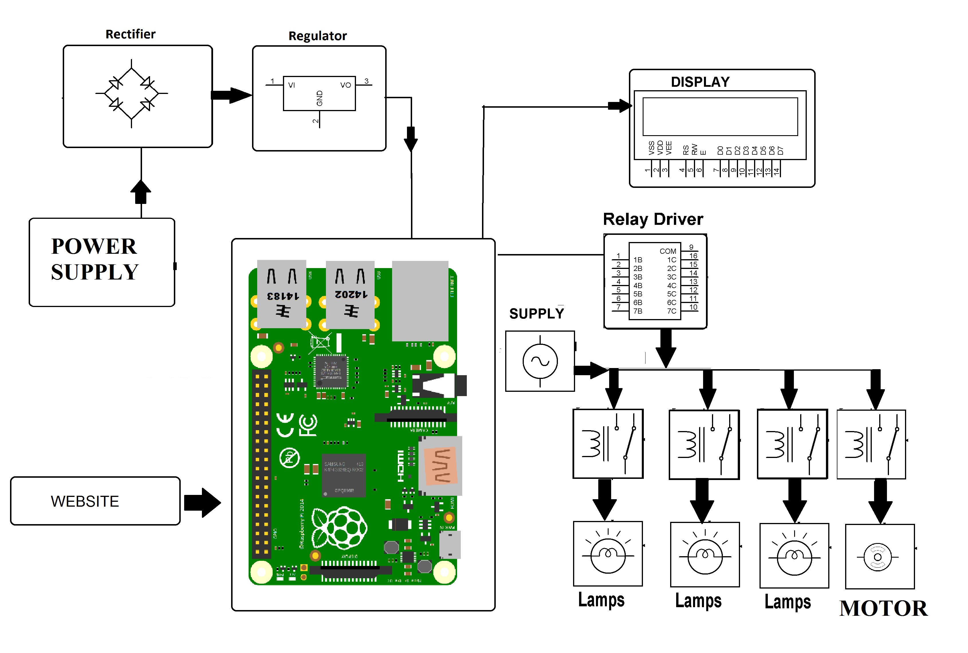

Hardware Specifications
- Rectifier
- Regulator
- LCD display
- Raspberry Pi
- Power Supply
- Lamps
- Motor
- Resistors
- Capacitors
- Diodes

Software Specifications :
- Linux OS
- IOT Gecko
- Programming Language: Python

